

**National University of Sciences & Technology**

**School of Electrical Engineering and Computer Science**

**Department of Computing**

**CS-344: Web Engineering (3+1)**

**BSCS-9C Spring 2021**

**Web Engineering Semester Project**

**SUBMITTED TO:**

**Dr. Qaiser Riaz**

**SUBMITTED BY:**

**Uzair Khalid (295913)**

**Sheroz Khan (284093)**

**Moiz Zubair (285266)**

**Muhammad Afnan Shakeel(293394)**

**Date of Submission: 14th June, 2021**

Contents

**Introduction:** 3

**Motivation** 3

**Our website:** 4

**Front page:** 4

**Product page:** 10

**A cart:** 11

**Login page:** 12

**Registration page:** 13

**Admin panel:** 13

**The Layout** 14

**Screenshots:** 15

**Functional and Non-Functional requirements:** 16

**Functional Requirements:** 16

**Non-functional Requirements:** 17

**Conclusion** 17

# **Introduction:**

Our group decided to work on an E-commerce website because we believe that an ecommerce website is essentially a project that is both equally frontend and backend heavy. As we had already got much of an exposure of the frontend in our labs, we wanted this time to focus more on the backend and hence for this reason while our project may not seem extremely fancy on the frontend, we deliberately choose a minimalist design approach, the backend working is where it completely excels and shows its true potential as almost all of our website is completely dynamic and not only that we also took care and made sure to perform this task as efficiently as we can and not making unnecessary requests to the server. Our journey started with a debate of whether to go with a single page application using Angular or to use simple HTML, CSS and JavaScript. The decision was highly motivated by the number of resources available online in this regard because since this was our very first time working on a big scale, we definitely needed much help and once we are on our way, we can then be all by ourselves. After a lot of consideration, we choose to work with multi page application for the following reasons:

* Simple and easy to start with and also easy to link with php. If we were working with Angular, we had to first learn a little bit of node to link it up with php and helpful resources for such were not available online because rarely anyone uses php with Angular.
* We had already been working with Angular in our recent labs and we didn’t want to get into a habit of always working with single page applications and rather still polish our core HTML, CSS and JavaScript concepts.
* Most E-commerce websites like Amazon, eBay and our very own Daraz.pk are multipage websites.

# **Motivation**

The idea of an E-commerce website popped in my head (Sheroz Khan) when one of my uncles recently started a business venture in Islamabad which happens to be a shoe store. He asked me if there’s a possibility that I could make a basic website for his store so that he can make online sales given the tough covid crisis we are in and lockdowns happening every now and then. In the same time frame, we were asked to decide our web projects and I discussed this opportunity with my group members because this would serve as a golden opportunity to actually deploy our first ever full fledge web project. Luckily, we all were on same page and decided to work towards this goal so while our short-term goal going forward with this project is to actually to gain good marks in our project but our long-term goal is to deploy this project live when it is fully functional and capable with all the features in working condition. It was initially decided that we will try to add maximum functionality till the project deadline and leave the final bits such as adding an actual payment gateway like Jazz Cash to be done later after ESEs. With all our realistic goals in place we were set to start this amazing journey.

# **Our website:**

Since it was already decided that our website is going to be minimal and easy to use for the customer without fancy stuff and complications which add a dodgy experience for the end user at times. An example would be daraz.pk as it has extremely long loading times at occasions due the unnecessary animations, banners and scripts which in our opinion just serve a bad experience to the end user. If I’m to buy shoes I simply want them to be displayed straight up with the prices and comparisons for me to choose. This develops best experience in our opinion and actually motivates the user to buy stuff rather than him/her searching, browsing and continuing being stuck in this loop forever.

We started searching for something similar on YouTube as a reference to follow but never really found anything that was completely fit to our liking. All the tutorials were lacking something or the other. For this reason, we decided to pick and choose parts from the tutorials we like and implement them to our taste. We had to also be extremely careful of the copyright because we intended to deploy it in the end. The design we ended up with was essentially;

* A front page with multiple dynamic sections and subsections which will be explained below, we primarily wanted almost all our customer targeted sections to be displayed on the front page.
* Dynamic Products pages displaying the info of all the products.
* A login pages.
* A registration page and finally;
* A cart
* an Admin panel containing multiple pages itself for the admin side to add, remove and check products on the website.

## **Front page:**

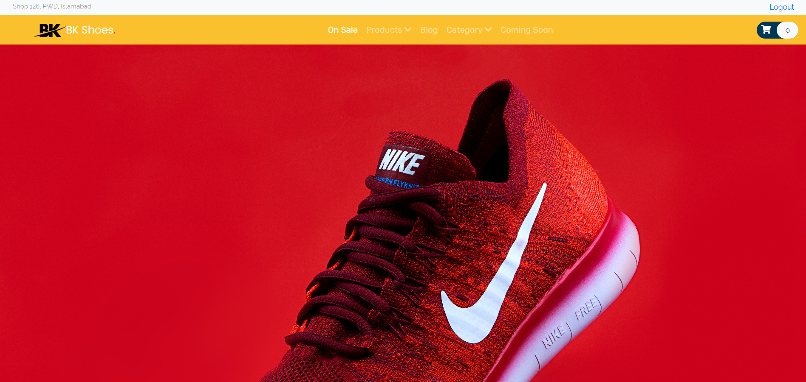

We created front page which welcomes the user with our beautiful navbar + a pre navbar section, the navbar contains the shop logo, name and essential navigation links to other pages, it also includes a cart logo taken using the font awesome icons CDN which can be clicked to go to your custom cart. The logo and name are also clickable so you can quickly navigate to the home page from wherever you are. The pre navbar section also serves a very important purpose, it points the user to notice the shop address quickly also holds the login button in place so that login is quickly identified by the user.

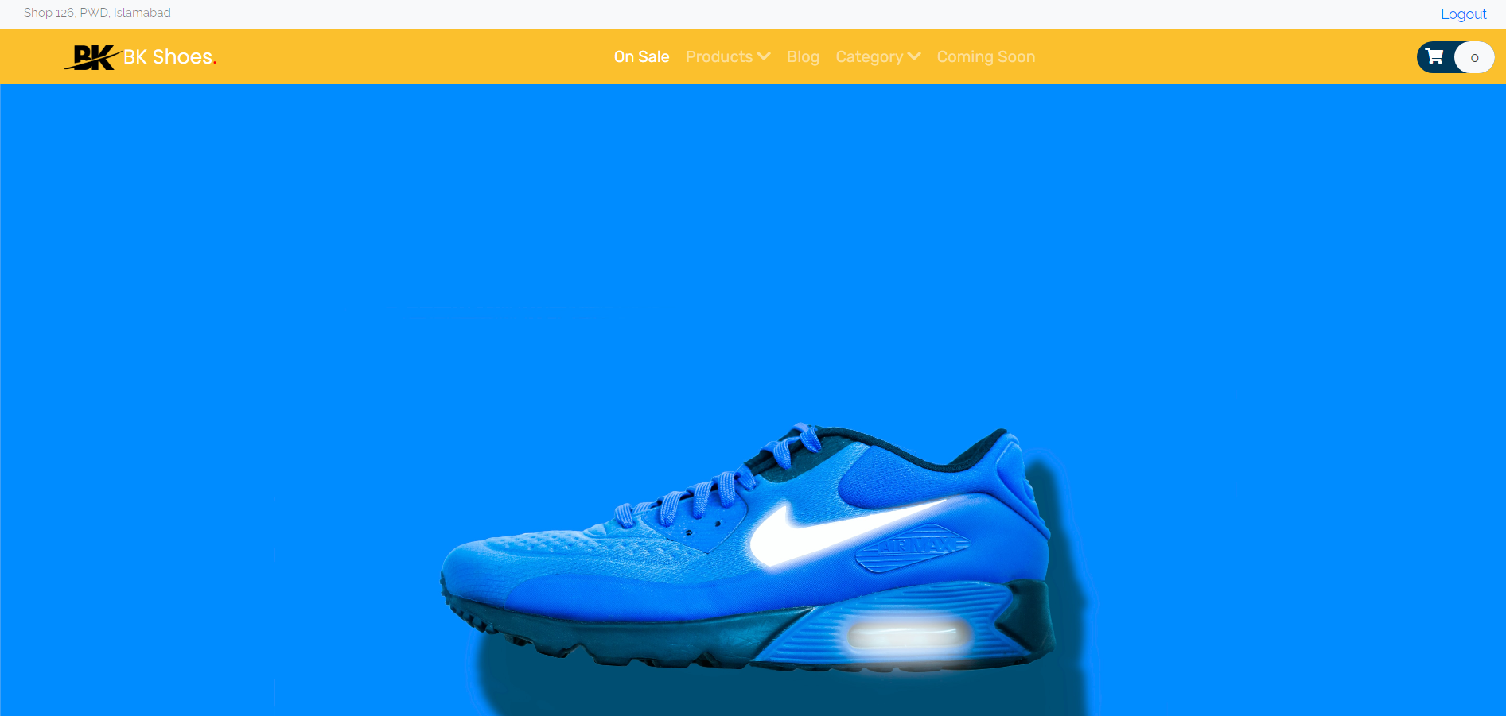

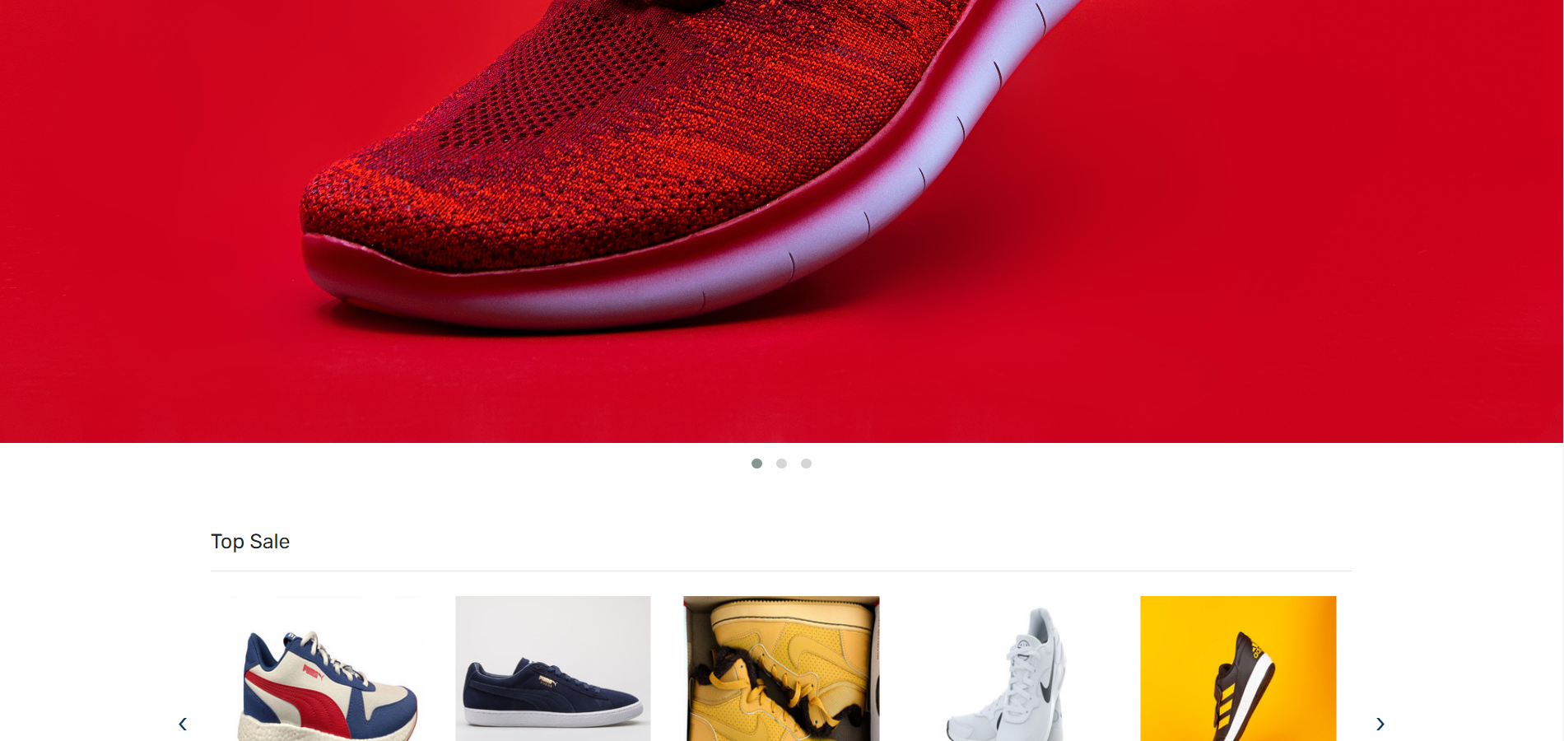

Following the Navbar the customer is welcomed with a beautiful carousal of high-quality shop/shoe images to spark their interest in either buying the shoes online or just simply visiting the shop themselves. To achieve this carousal, we used a jQuery plugin known as owl carousal. It was a bit of a learning curve but it was all worth it.

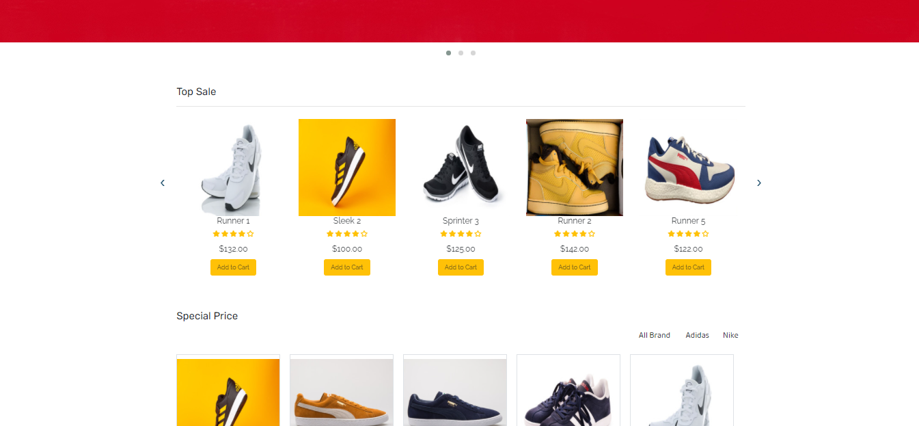

Following the carousal is a Top Sale section which includes all the products which are in hot selling, it has a slider action so they can be slide left and right using either touch or the button arrows which are given on the left and right of the section. Each product in the section is essentially a subsection of the Top Sale section. It contains dynamically pulled image of the shoes from the database, the price and the ratings, and finally the it also has an Add to cart functional dynamic button which adds the product to your cart for purchase or to be added to Wishlist later. If a product is already added in the card the button becomes green disabled and says In the cart already. It also has a beautiful mouse hover animation applied on the product images through CSS and JavaScript.

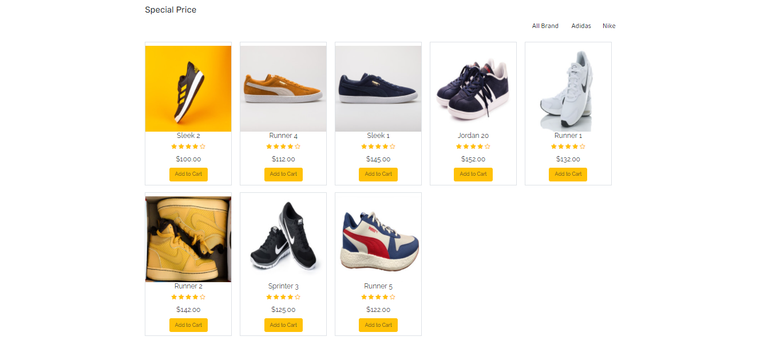

Following the Top Sale section is the Special Price section which is one of our most liked features of this website. It essentially resembles the Top Sale section however it serves its own purpose. The Special Price section can dynamically filter products based on the company of the products. In the screenshot you see four options which include: All brands, Adidas, Nike and Puma and the section is able to filter out products based on what you have selected not only that if the admin adds a product with a new company the section is able to identify that dynamically through the amazing php code we have written and it displays the company as a filter and automatically filters its products.



Following the Special Price section, we have the banner section which we kept for later to be populated with sponsored ads to other websites or just simply for new promotions on our website to engage the user.

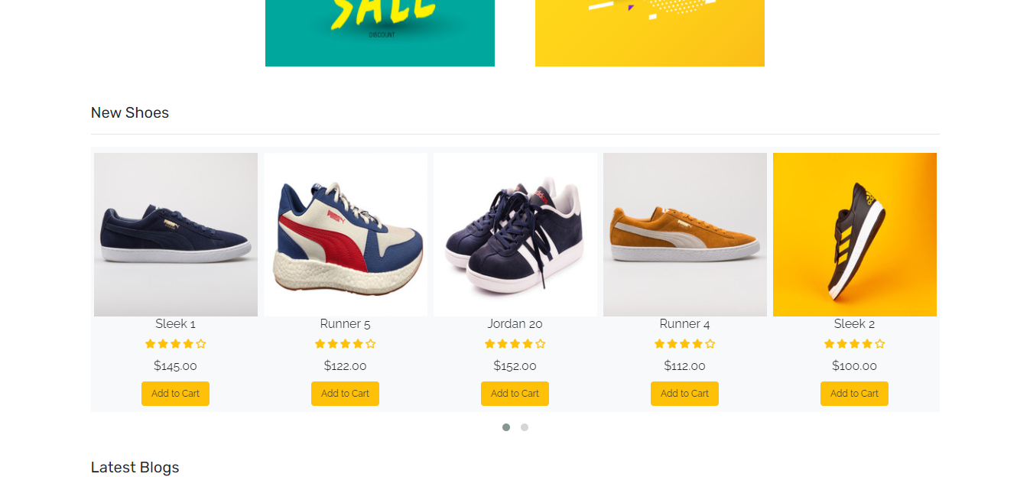

After the banners have the new shoes section which contains the new shoes on our website and its quite similar to the Top Sale section but it uses carousal navigation.

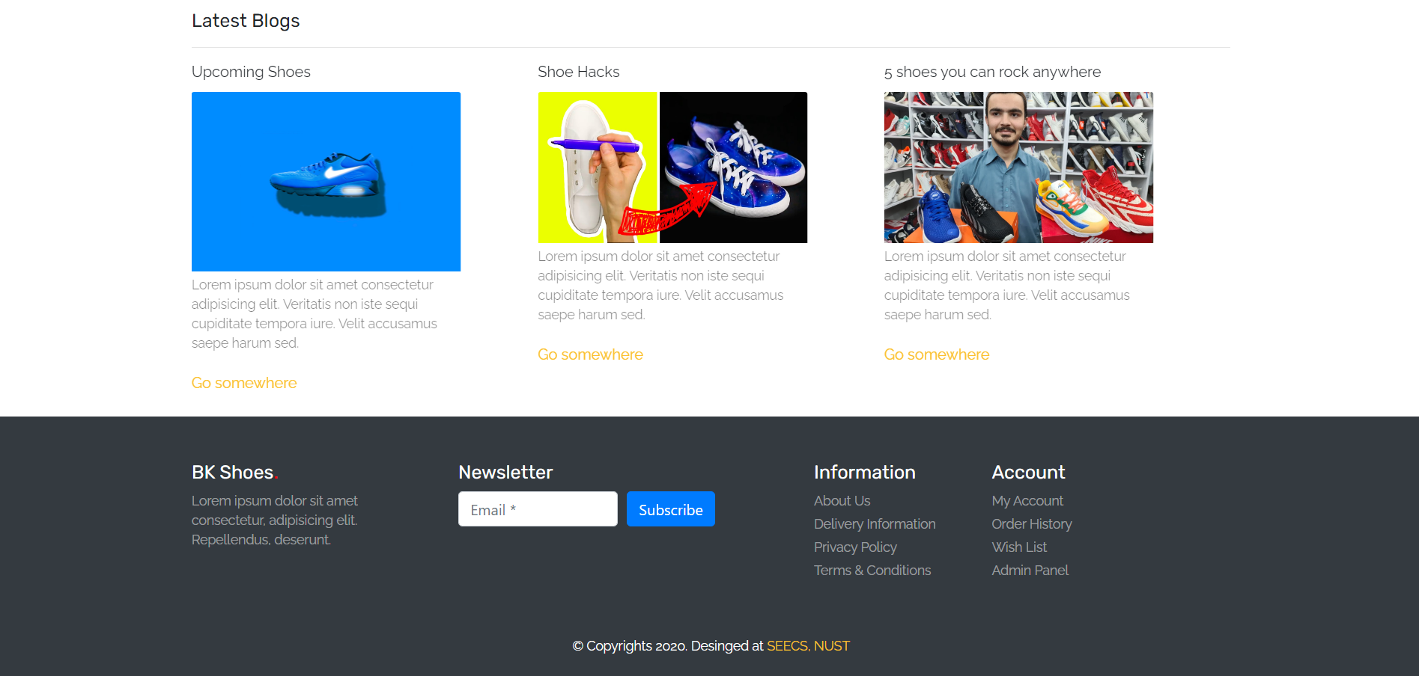

Lastly, we thought it would be nice to add a latest blog section before the footer which would contain blogs and hacks related to shoes to engage the user.

The footer contains a subtle option to subscribe for our newsletter, essential information and account links which work dynamically. It also contains the link to our Admin CMS.

## **Product page:**

If you click anywhere on any product on our website it will land you to our product page which contains all the essential details about our products that you have clicked. It is able to pull this information dynamically. Besides the header and footer, our product page had essentially three main sections sections/divs.

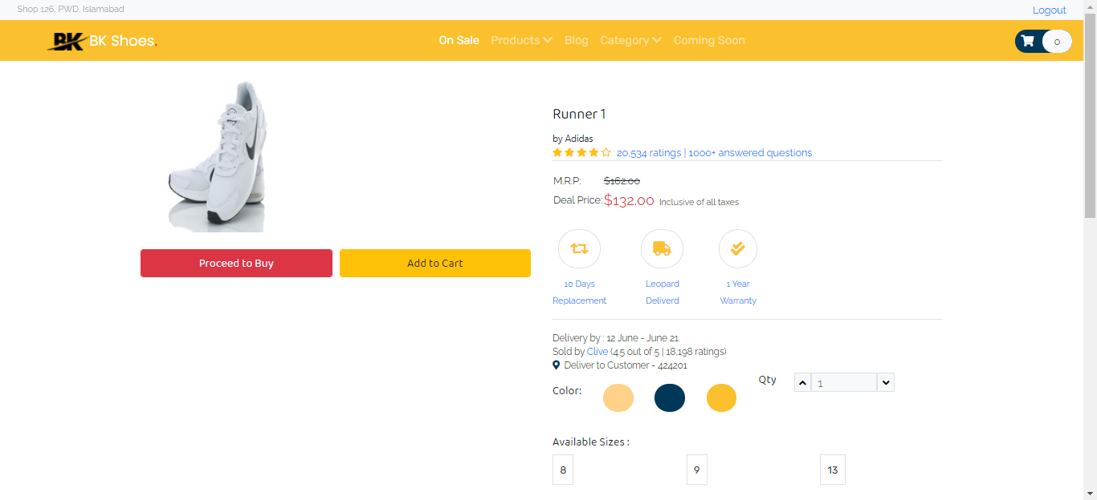

1. The first section is again divided into two sections, the first one has dynamically pulled product image and buttons to purchase directly or add to cart and second section parallel to it contains the dynamically pulled product name, company and price along with other beautifications. You can also dynamically decide the quantity you want to buy.

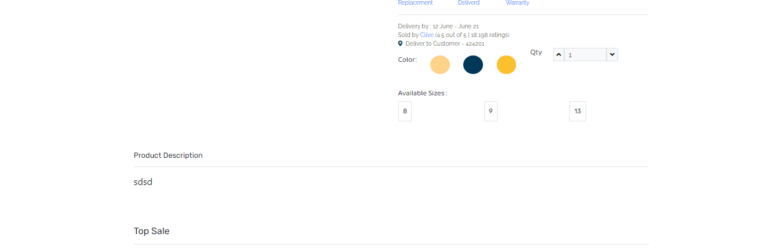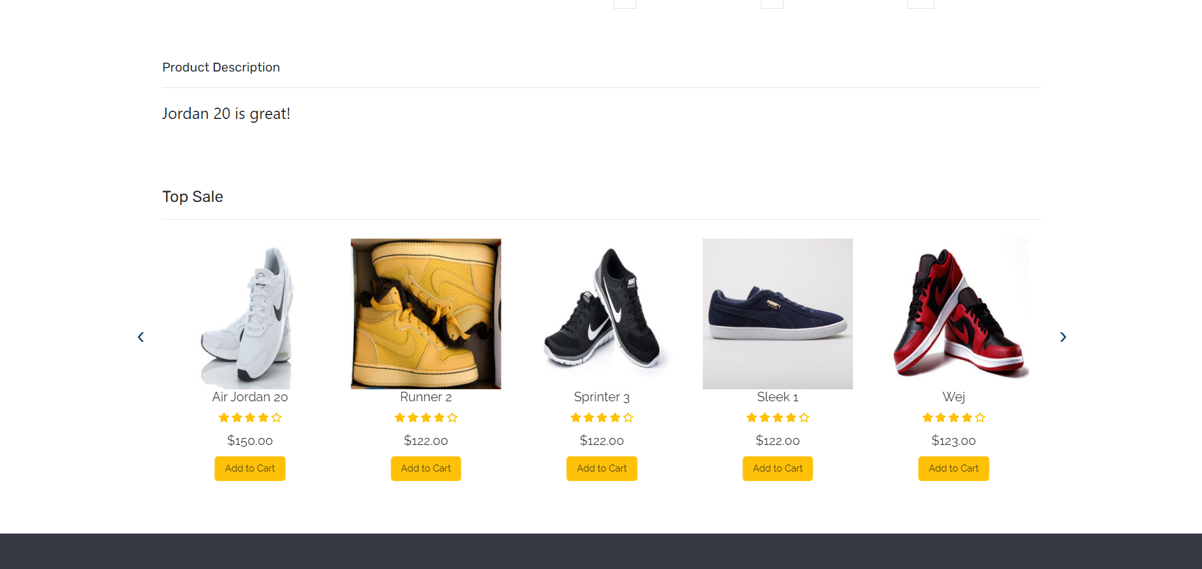

1. The second section contains a div which pull the project description from the database.

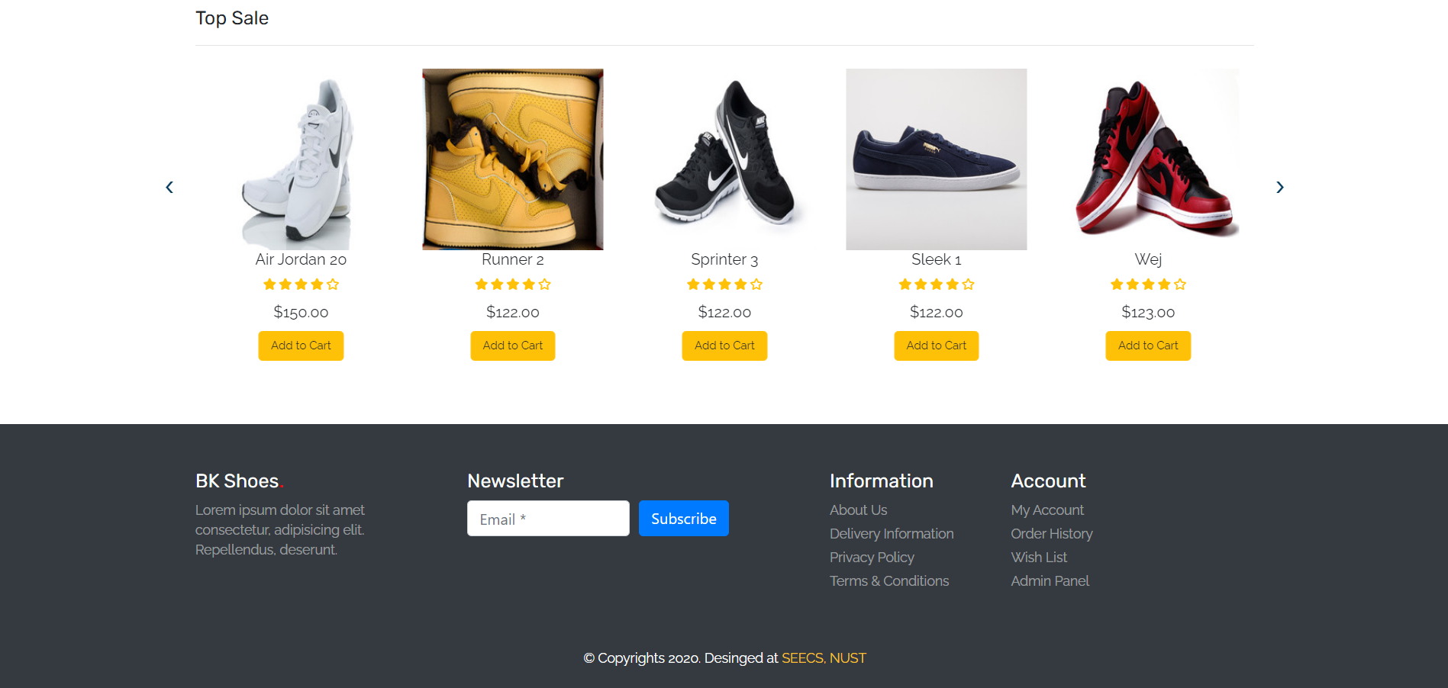

1. The third section is the Top Sale section we explained earlier.

## **A cart:**

Our cart dynamically displays the products in cart, dynamically calculates the subtotal and also allows user to change the quantity while dynamically updating the subtotal. It also has a Wishlist option if you want to buy something later. You can delete a product or add that to the Wishlist.

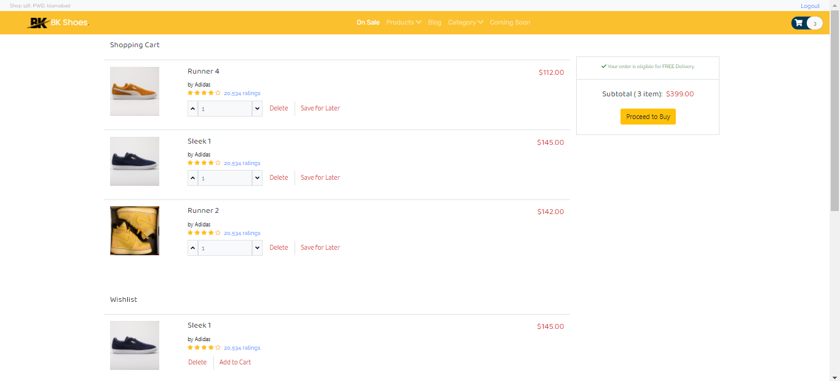

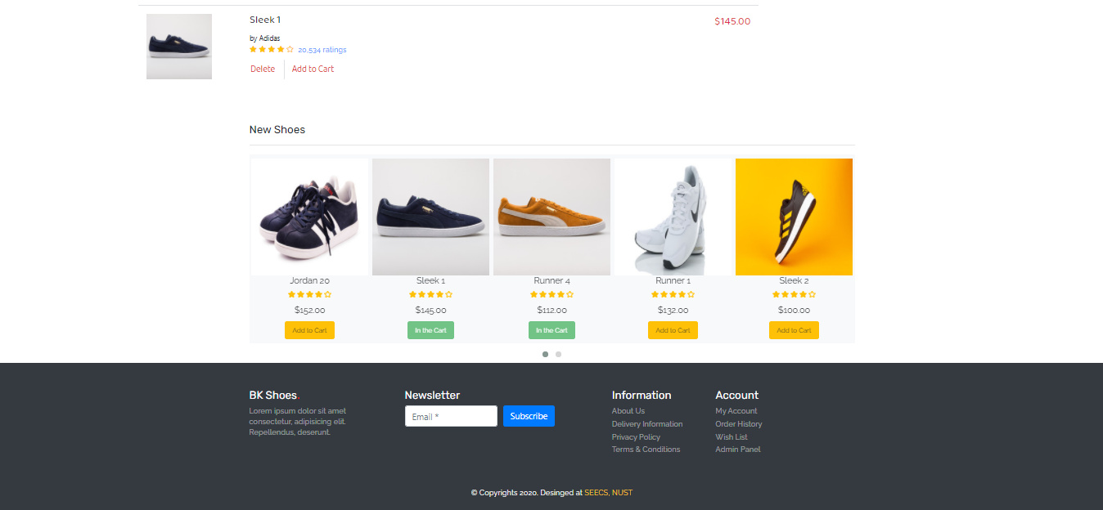

## **Login page:**

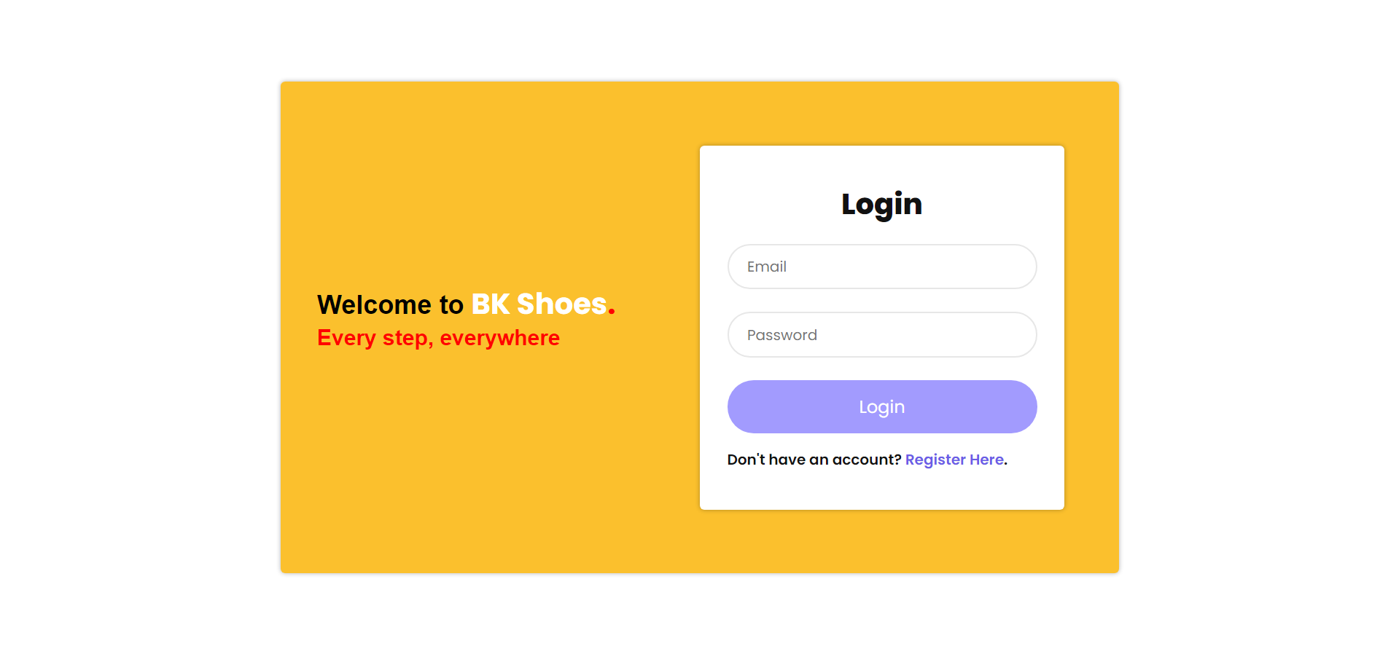

The login page a simple and beautiful login portal which allows the user to login to the website if they are already registered. If you are not registered you can click on registration here and register yourself on the registration page. If you are not a user and try to login, our login page will not validate you and echo a warning.

## **Registration page:**

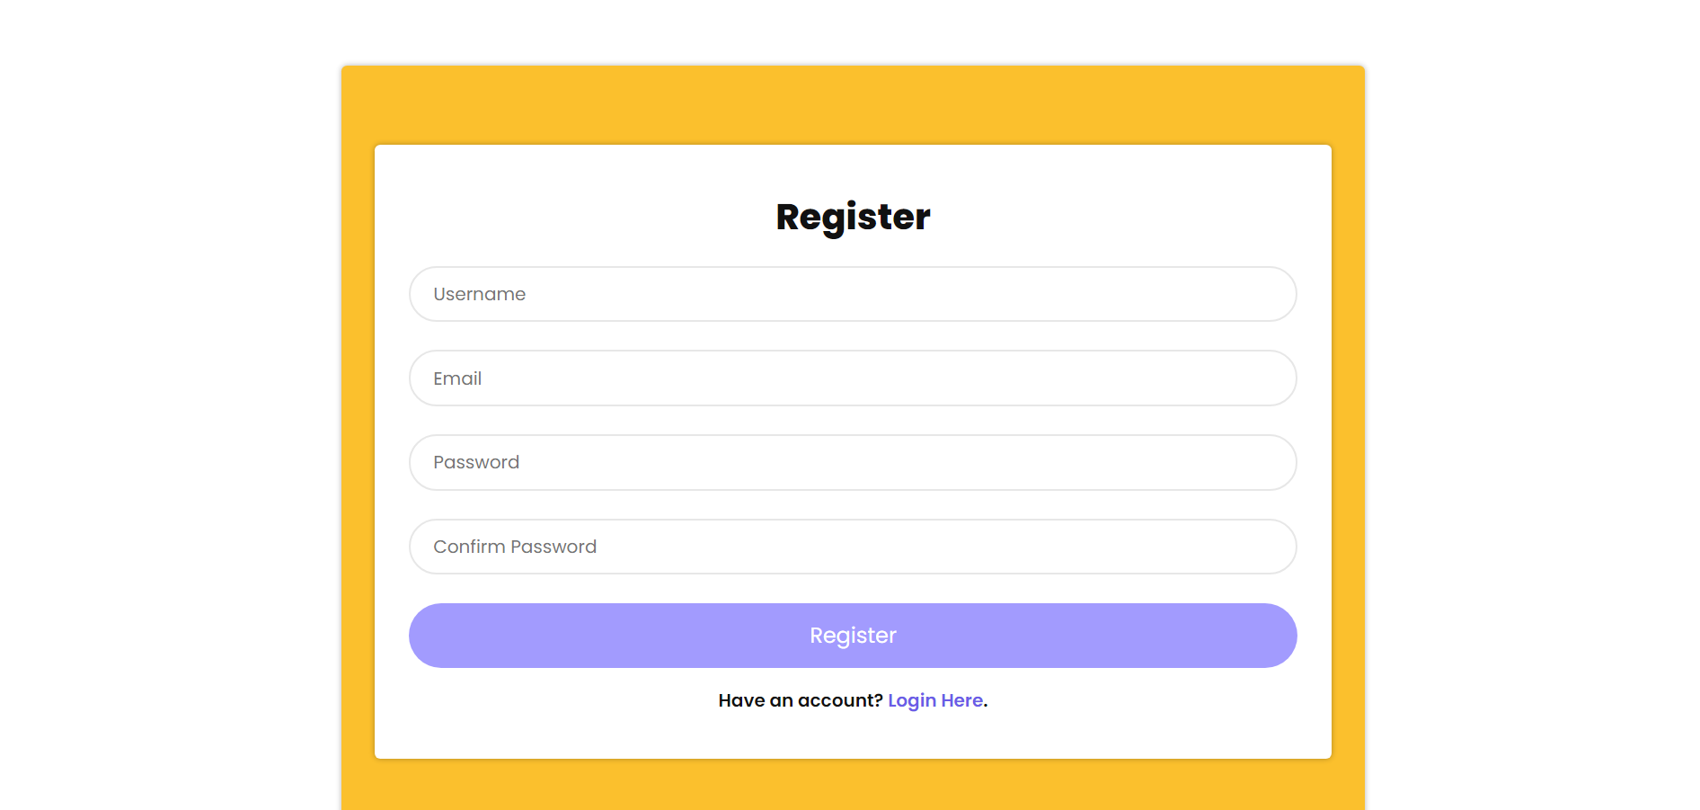

The registration page was deliberately kept simple and to the point for the user. It allows you to quickly register yourself on our websites database using the beautifully designed registration form. Once you fill the form click register and your registration will be kept safe in our backend you can than go back and trying logging in to our amazing website.

## **Admin panel:**

The admin panel essentially had 5 main functions which were directly connected the Database:

**SHOW PRODUCTS, ADD, DELETE, EDIT**

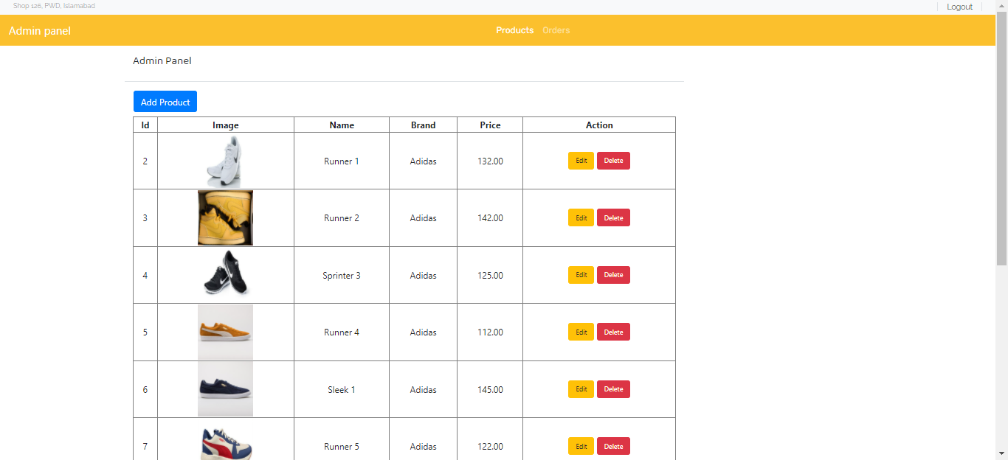

**ADD**

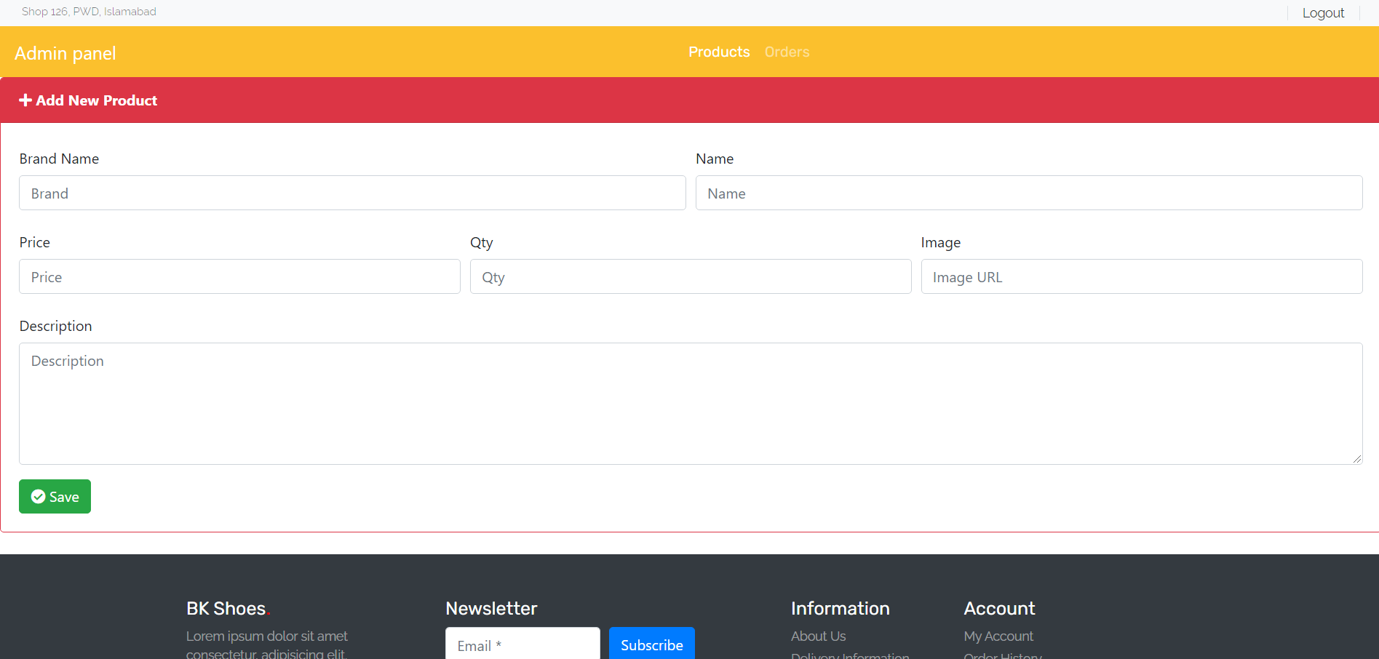

**DISPLAY ORDERS**

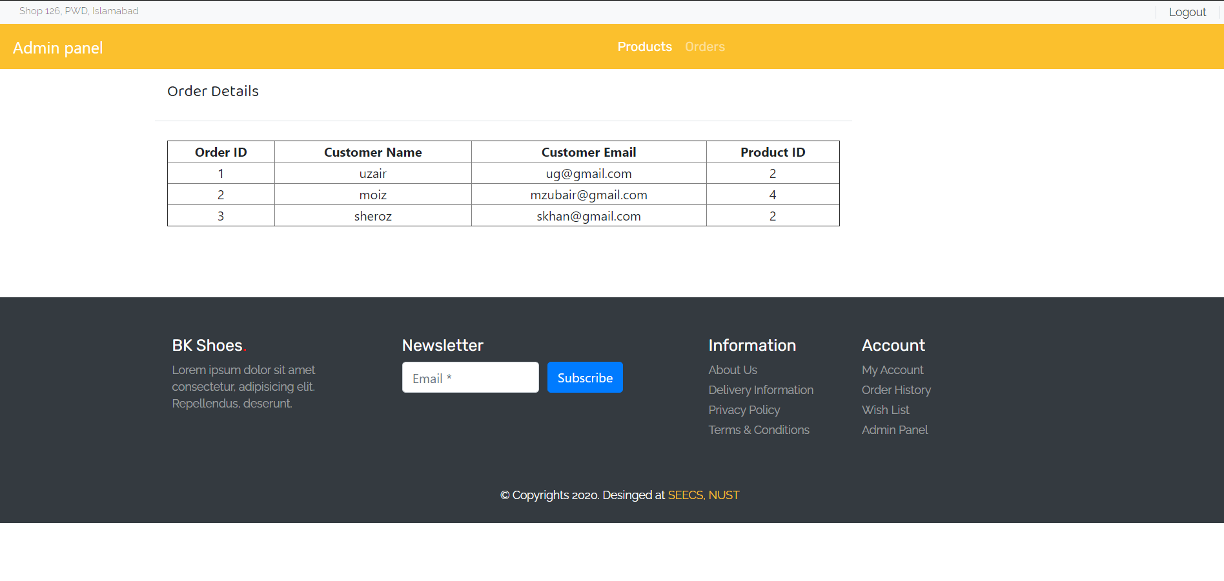

# **The Layout**

When we were to start our website, we decided to use bootstrap to make our website responsive along with using it beautifications. Using bootstrap, we were able to divide the sections to adapt to a certain column given the device width for the most part. Using the owl carousal, we were able to give it a certain width to adapt according using JavaScript. The end result was that our website is responsive for the most part and it can be best proved by the screenshots in the following section.

## **Screenshots:**

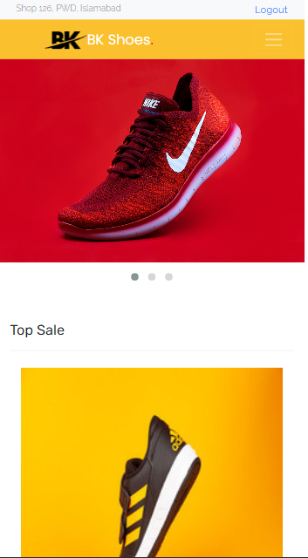 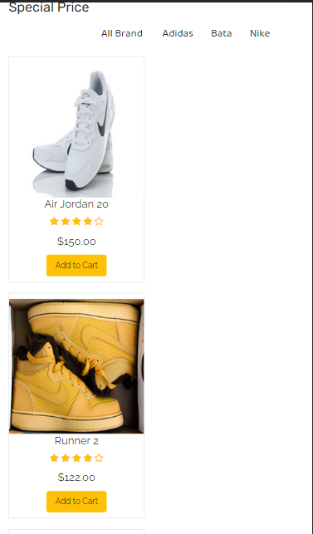 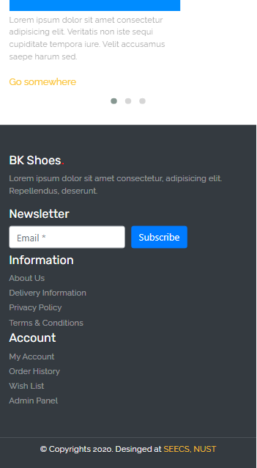

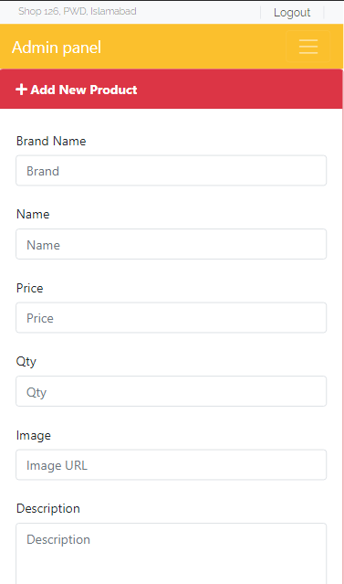 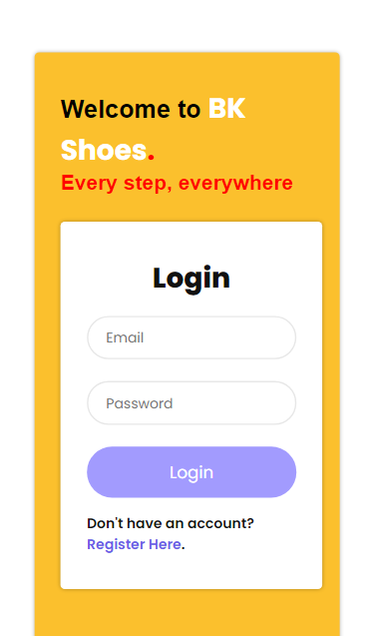 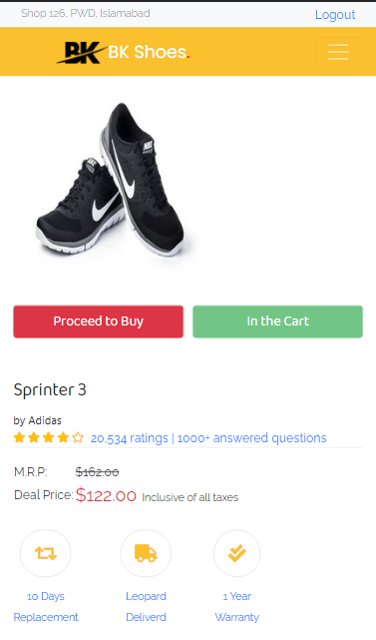

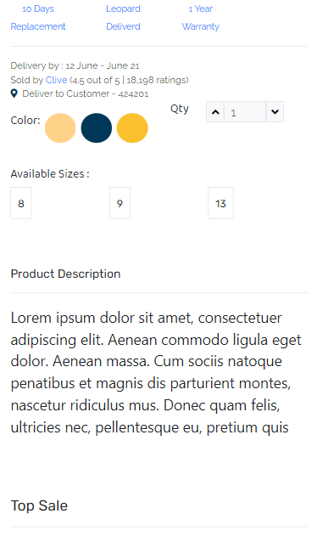 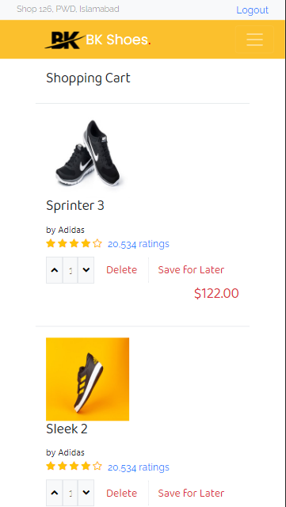

# **Functional and Non-Functional requirements:**

Since this was our very first time setting functional and non-functional requirements, we may or may not have actually identified them accurately but we tried our best. We took the liberty of the fact that since there was no actual client in our project case it was more of an informal functional and non-functional requirement setting. The functionals requirements of our project included;

## **Functional Requirements:**

* The website will authenticate the user if he/she tries to login
* The total price of the cart will be dynamically calculated
* The products each will essentially have its separate page along with a unique address but will be rendered by the same php page to reduce the consumption burden of the system.
* The website can used as any E-commerce store for which all the data has to be dynamically pulled from a database.
* The use technologies include: HTML, CSS, JAVASCRIPT, PHP, SQL, NODE NPM, JQUERY, BOOTSTRAP, SASS COMPILER, OWL CAROUSAL, FONT AWESOME ICONS AND GOOGLE FONTS. Most of these were included using their CDN to keep the project size small.
* The database to be used will be a relational database and we ended up choosing SQL.
* The user is able to browse and filter the products on the website.
* The user is able to add the products to the cart and decide the quantity dynamically.
* The user is able to create a Wishlist.
* The user is able to register and also login in to the website to maintain their cart and orders.
* The user is able to logout of the website.
* The user is able to open a product page and find all the necessary information about each product.
* The website Admin is able to authenticate himself.
* The website Admin is able to add new products, remove products and check all products on the website once authenticated.

## **Non-functional Requirements:**

* The user must be able to browse all their required products without the actual need to searching for it.
* The user smooth browsing experience can be aided by using natural navigation systems like touch navigation and carousal navigation.
* User is redirected to appropriate pages if something isn’t right or authentication fails.
* All the elements, images and themes used must be copyright free for commercial use.
* Our website should achieve faster loading times than similar competitors.
* Page reloads should be minimum/minimum possible php request should be made.
* Payment gateway should be secured.
* The website should understand the user psychology and put sections appropriately where needed instead of spamming like daraz.pk
* Speed of click interactions must be fast.
* User or the Admin should have nothing to do with the backend database and all the database should be managed using interesting frontend UI.

# **Conclusion**

All in all, we believe that this project served a great learning experience for us. We are quite happy that we were able to achieve our initial goal of polishing our backend skills with extra focus. Throughout the process we came across problems bugs where we were almost about to have a mental breakdown but we never gave up and stayed firm, kept trying and we are quite happy with our end result. We were able to learn new technologies such as php, jQuery, etc. It also helped us polish our database skills as the project required some extensive SQL to manage the backend. Although we are extremely happy with what we have achieved so far but that doesn’t necessitate that our final goal is done, we still have a long way to go as we would like to add more features to the website such a payment gateway, refine existing features such a refined version of the admin panel, an extensive database which has all the relations and entities needed for our frontend, some cool JavaScript animations and finally add the original products on the website and create its original database. We would also like to host our website. So essentially this project has served its core purpose of giving us a starting point and now it’s about time that we start refining it until we feel it’s ready for launch. We would also love some user to test our website to identity the small bugs here and there and report to us before the final launch.